Bash Scripting Task 2

**# If-then Scripts:**

1. **Check the variable**

With correct number 100  
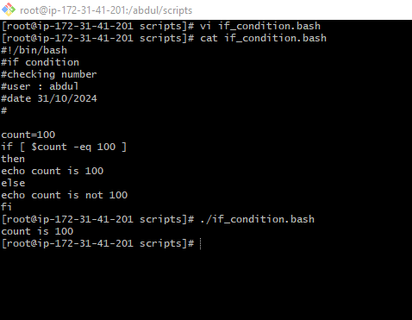

With Number 20  
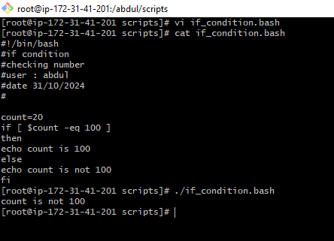

1. **Check if a file error.txt exist**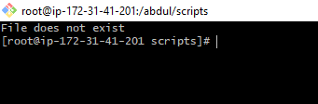
2. **Check if a variable value is met**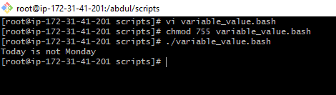
3. **Check the response and then output**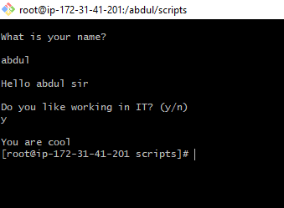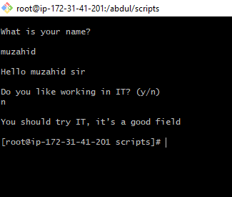

***# for* loop Scripts**

**simple for loop output**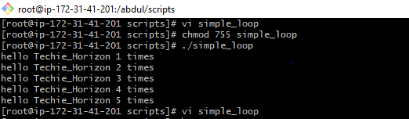

**simple for loop output for 50 times**

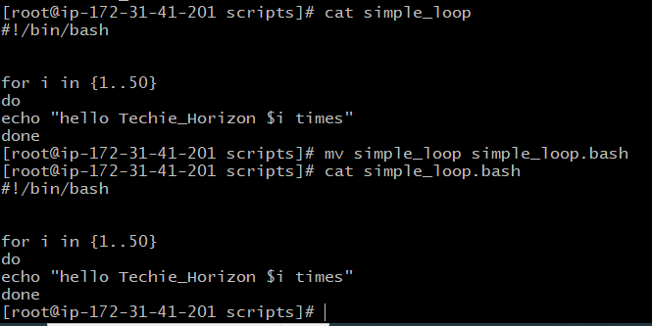



**Simple for loop script**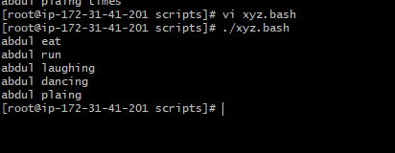

**for loop to create 5 files named 1-5**

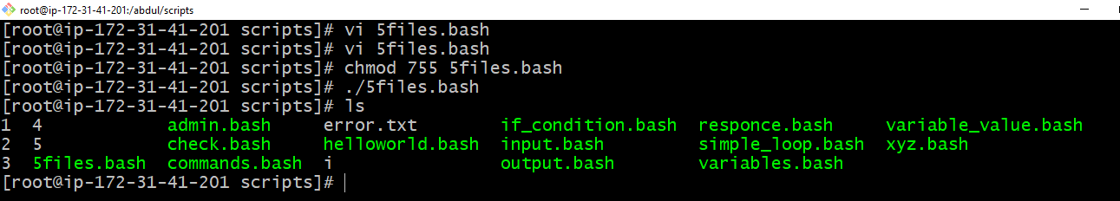

**for loop to delete 5 files named 1-5**

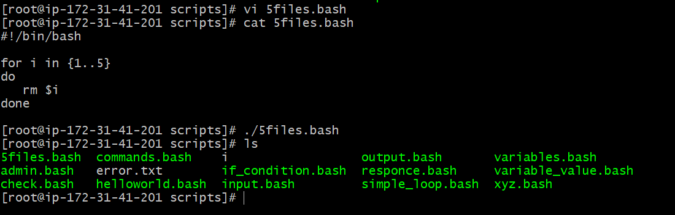

**Specify days in for loop**

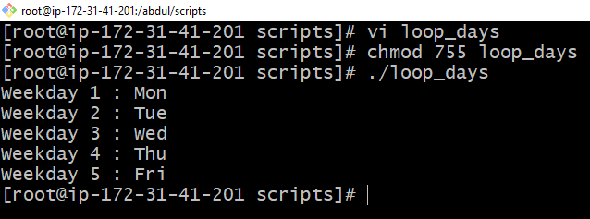

**case Scripts:**

**Case Scripts:**

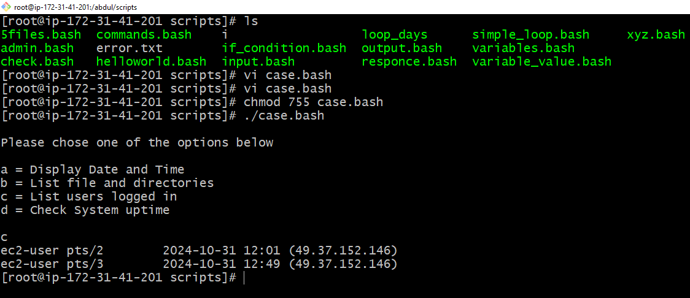

**#do-while Script**

**Script to run for a number of times**

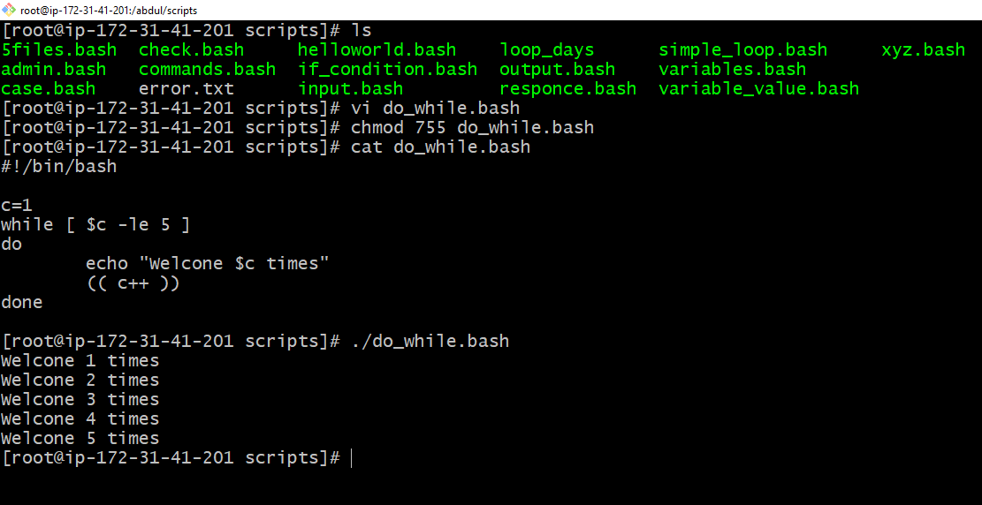

**Script to run for a number of seconds**

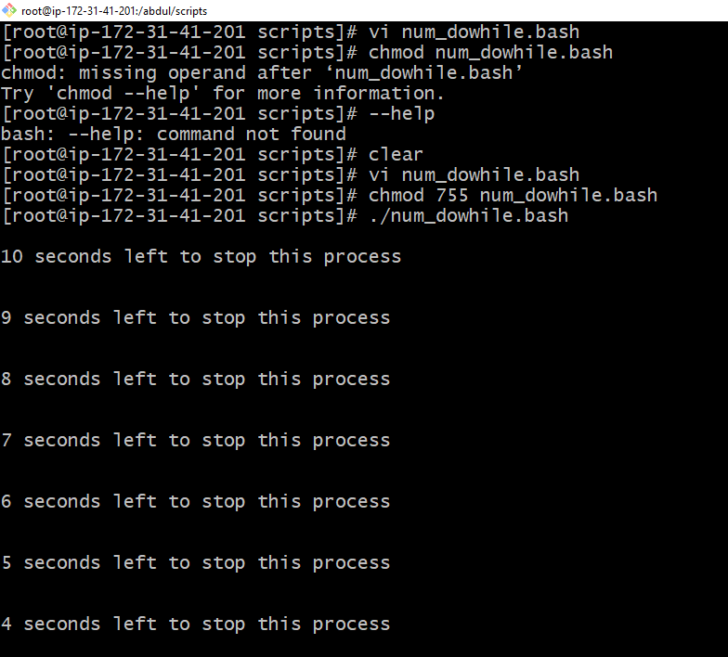

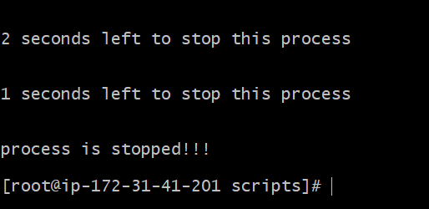

**Basic Shell Scripts:**

**Output to screen**

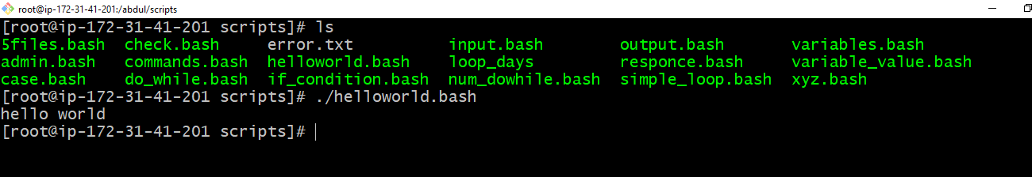

**Defining Tasks**

